Key Milestone 1

# Group Members

Muhammad Waseem (22PWCSE2180)  
Sharjeel Qureshi (22PWCSE2199)

# 1. Entity Description

The table outlines the primary entities involved in the Municipal Complaint Management System.

|  |  |
| --- | --- |
| Entity Name | Description |
| User | Represents a citizen who submits a complaint. |
| Complaint | A reported issue related to municipal services. |
| Department | The municipal department responsible for handling complaints. |
| Admin | Municipal officer who monitors and updates complaint status. |

# 2. Detailed Business Rules

1. Each user must register with a unique email and phone number before submitting a complaint.

2. A user can submit one or more complaints.

3. Each complaint must be associated with a registered user.

4. Each complaint must be assigned to exactly one municipal department.

5. Each department can handle multiple complaints.

6. Each complaint must have a status: Pending, In Progress, or Resolved.

7. All complaints must be timestamped upon submission.

8. Admins are responsible for updating complaint statuses.

9. Each complaint must include a brief but clear description.

10. Only Admins can update or close a complaint.

# 3. Entity Relationship Diagram (ERD)

I refer to the ER diagram created in draw.io using the structure below,

Entities:  
- User (User_ID, Name, Email, Phone)  
- Complaint (Complaint_ID, Description, Date, Status, User_ID, Department_ID)  
- Department (Department_ID, Department_Name, Contact_Info)  
- Admin (Admin_ID, Name, Email, Role)  
  
Relationships:  
- User submits Complaint (1:N)  
- Complaint is assigned to Department (N:1)  
- Admin manages Complaint (1:N)

# 4. Enhanced Entity Relationship Diagram (EERD)

This is EER diagram which I created in draw.io which includes the generalization of User into Citizen and Admin.

Generalization:  
 User → Citizen  
 User → Admin  
  
Other Entities:  
- Complaint (linked to Citizen via User_ID)  
- Admin manages Complaint  
- Complaint assigned to Department

# 5. Flowchart of Complaint Lifecycle

flowchart illustrates the complete complaint lifecycle process:

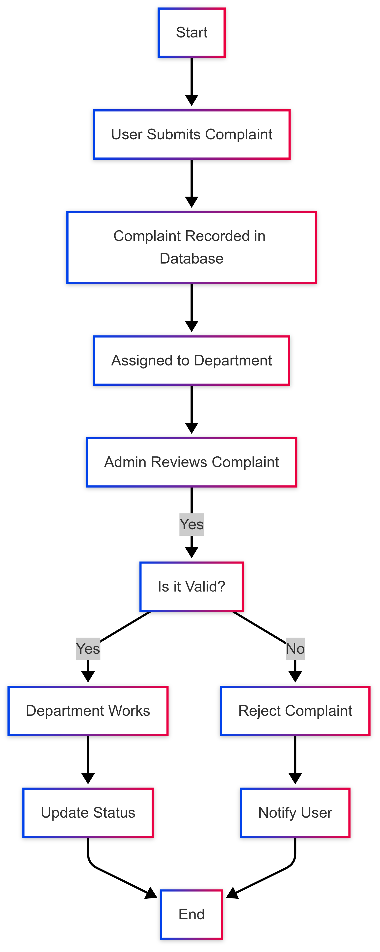

# 6. References

- Lecture Slides – DBMS Course: Lecture 2b, Lecture 3

- draw.io (diagrams.net) – for diagram creation

- ChatGPT by OpenAI – for guidance and structuring assistance